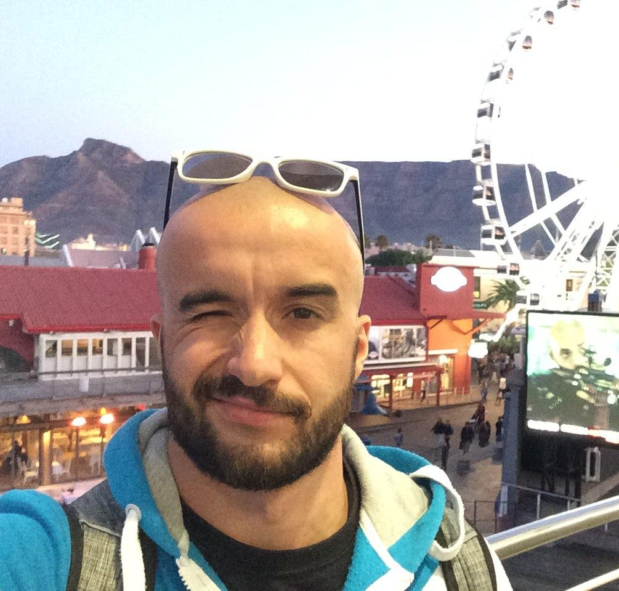
            - Dmytro Grendach

Web: https://grendach.github.io/cv
E-mail: grendach@gmail.com
Mobile 1: +48 883 644 1 64
Mobile 2: +38 066 644 1 644
Date of birth: June 25, 1985
Marital status: married

Key competence:

- DevOps engineer with bash and Python experience.
- Working with Docker, Kubernetes, Terraform, Ansible, Packer, Helm, Rancher, Kafka, Prometheus, Grafana, CouchDB, GitLab, GitHub, TeamCity, Jenkins, Spinnaker, ELK etc.
- AWS, OpenStack cloud providers.
- Linux administrator skills.
- Almost 10 years of experience as an integration engineer in Telecom projects all over the world.
- Deep understanding of network (TCP/IP) protocols and OSI model.
- AWS Certified Developer – Associate (expired: 8/14/2028)
- AWS Certified Database – Specialty (expired: 4/29/2027)
- AWS Certified Solutions Architect – Associate (expired: 7/4/2026)
Education:
- 2002-2007 Poltava Institute of Telecommunications
Degree: specialist.
Specialty: engineer of informational systems.
- 2018 Wroclaw Economical University
Specialty: project management.

Additional training:
- 2008 - installation of Huawei routers.
- 2010 - Oracle Database 10g: SQL Fundamentals I.
- 2013 - Java learning courses, Basic level.
- 2014 - Presentational skills.
- 2014 - Design of microwave transport network.
- 2015 - WCDMA protocols and RNC integration.
- 2018 - conferences: GoLab, CoDe, OpenStack days.

Languages:
- Ukrainian - native speaker.
- English - advanced.
- Polish - advanced.

Working experience:

1) 10.2022 - till now: DevOps engineer in Siemens Digital Industries Software (Katowice, Poland) is an American computer software company specializing in 3D & 2D Product Lifecycle Management (PLM) software. The company is a business unit of Siemens, operates under the legal name of Siemens Industry Software Inc, and is headquartered in Plano, Texas.
Responsibilities:
- Build, implement, and support CI/CD processes and tools on all stages
- Build IaaS on AWS, using microservices on Docker containers.
- Maintain dev/preprod/production infrastructure
Key achievements:
- Deploy CI/CD pipelines from scratch

2) 08.2020 - 10.2022: DevOps engineer in a Confidential company (Abu Dhabi, UAE)
Responsibilities:
- Build, implement, and support CI/CD processes and tools on all stages.
- Build IaaS on Bare Metals, support legacy ansible deployment, microservices on Docker containers.
- Maintain dev/staging/production infrastructure for four development teams.
Key achievements:
- Participate in recruiting process
- Deploy CI/CD pipelines from scratch
- Act as a Solution Architect and Network designer
- Setup K8s cluster on VMWare and migrate services to it.

3) 05.2019 - 06.2020: DevOps engineer in JustEat (Kyiv, Ukraine). The platform enables customers to search for local take-out restaurants, place orders, pay online, and choose from pick-up or delivery options.
Responsibilities:
- Build and maintain CI/CD processes and tools on all stages.
- Support IaaS on AWS by Terraform, and Ansible, microservices on Docker containers.
Key achievements:
- Deploy and support Kubernetes cluster on a staging environment. Create custom Helm charts.

4) 01.2017 - 03.2019: DevOps engineer in Nokia (Wroclaw, Poland). Finnish multinational communications and information technology company, one of the leaders in the telecom market. Wroclaw R&D center.
Responsibilities:
- Create and maintain REST APIs for the BigData analysis platform.
- Creating microservices in Golang and Python.
- Debugging and problem-solving related to API.
- Technical support of Nokia mobile base station products (2G, 3G) for different customers (mobile operators) all over the world.
- Troubleshooting, deep analysis, and delivery to the customer of mobile radio services produced by Nokia such as software packages, patches, and updates.
Key achievements:
- Installing Kafka on the K8s cluster, customizing it to customer needs, exposing Kafka via Load Balancers, and creating Grafana dashboards for Kafka monitoring.
- Create REST API on Golang and Python.

5) 11.2015 - 11.2016: Software engineer in GlobalLogic (Kyiv, Ukraine). A company that provides full-lifecycle product development services, including experience design, product engineering, content engineering, and labs. The company specializes in big data and analytics, cloud, design, DevOps, embedded, Internet of Things, mobile, and security practices.
Responsibilities:
- Integration and support of OSS products for different customers (mobile operators).
- Server installation and their maintenance(OS Linux/Windows), Oracle WebLogic Server.
- Oracle DBA.
- Monitoring, performance, and optimization of OSS systems for mobile operators.
Key achievements:
- Installation of OSS system from scratch.
- Part of the performance team as an expert on OSS systems (monitoring load, servers, and services state).
- Implementing optimization solutions.

6) 06. 2011 – 11.2015: Integration and support engineer in Ericsson, multinational provider of communication technology and services. Responsibilities:
- Integration and maintenance of Ericsson products and services for mobile operators in the EMEA region.
- Integration of Linux servers and such equipment as RNC, NodeB, TCU MiniLink-TN(CN,LH).
Key achievements:
- Solution implementation on the network for mobile operators and modernizing existing networks.
- Development and designing of transmission networks for IPTV in Armenia.
- Process improvement of technical support for the customer.
- Can work as an integrator and support engineer with RAN and transmission equipment.

7) 11. 2006 - 06. 2011: System Administrator in Ukrtelecom, Ukrainian service and internet provider.
Responsibilities:
- Maintain IP television service.
- NOC engineer, working in shifts.
- Working with billing and monitoring systems (Cacti, Nagios)
Key achievements:
- My first working experience in a big telecom company where for one year I’ve made a pass from NOC engineer to the system administrator of the IPTV system.
- Able to provide good, stable, and modern service of TV streaming for end users.

